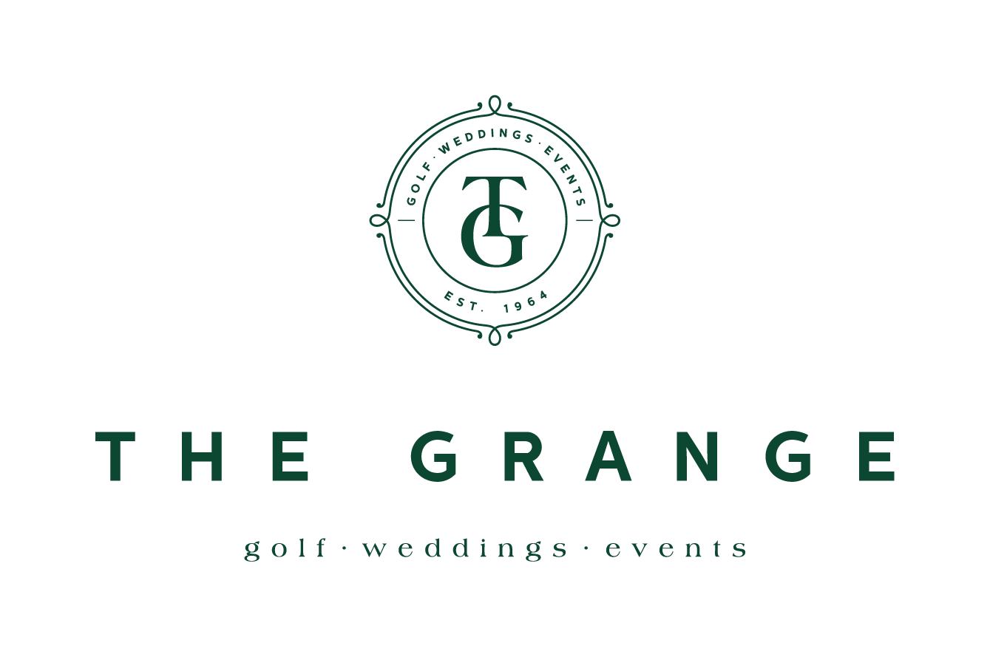

LADIES OPEN FOURSOMES
WEDNESDAY 24th MARCH, 2021
- Open to Lady Golfers with a Daily Handicap up to 54
- Gross and nett prizes
- Times available from 8am
- Payment to be made on the day of play
Sponsored by UNITED TECHNOLOGY

Entry Fee: $25 per player
GolfLink  Number | Name &  Phone No. | GA | GolfLink  Number | Name &  Phone No. | GA
Entries Close: Tuesday 16th March, 2021
Please contact Golf Shop directly to be included in the draw
02 42611647 Or email : proshop@thegrangegolfclub.com.au

Any Questions Contact Wendy Carlile ph 0417 256 995 or carlilepw@gmail.com

